PERSONAL HEALTH PLAN
DISCOVERING YOUR HEALTH GOALS
You are the ultimate owner of your life and your health. Being in the driver’s seat requires a good map. It is important to know your starting point and your destination. This means knowing what your health is like now and what you would like your health to be going forward. This may be a new way to think about your health. Many of us are used to thinking about our health only when we are sick. Whole person health and well-being mean understanding what your life goals are and what contributes to your sense of wellness over time.
A Personal Health Inventory follows this introduction. Please set aside some time to reflect on these questions, where you are now and where you want to be. We’ll review this personal health inventory together and use it as a tool to help you plan for your health in a way that fits your unique life and goals.
As you complete the Inventory, you may wish to refer to The Wheel of Health below and in the separate PDF handout. It visually represents the different interconnected and interrelated components of whole-person health and well-being. It considers the whole person-body, mind, and spirit-as well as community in which you live.
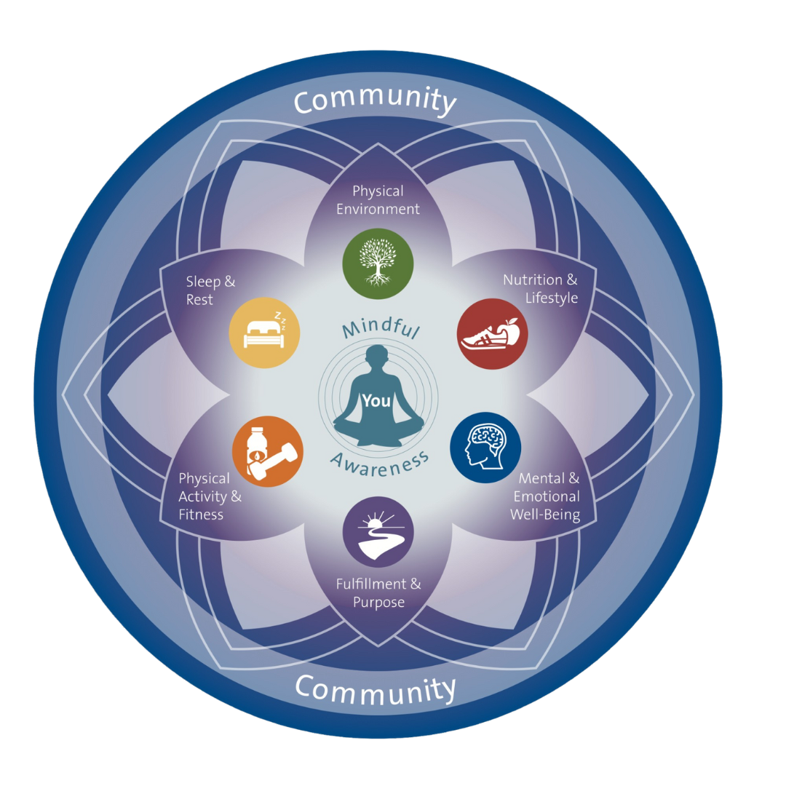

PERSONAL HEALTH INVENTORY

The first step in creating your plan is to complete a Personal Health Inventory to assess where you are now and where you want to be.
1. How do I picture my best health? How would I like to feel and look? What activities would I like to be able to do?

2. What is most important as I think about the picture of my best health?
3. For each of the 8 areas below, please take a moment to reflect on where you are now and where you would like to be. Please complete as many of the boxes as you can. You may want to start with the areas that are most interesting to you at this time. It is okay to just enter a number for each item, if you prefer.

Mindful Awareness
Mindful awareness is being fully aware and tuned in to what is going on right now, in the present moment.
On a scale of 1 (low) to 10 (high), how would you rate this area of your life?
Where are you on the scale now: | Where would you like to be:
Why did you choose this number? | What changes could you make you help you get here?

Community
A person´s community is built upon shared attributes of the people in it and/or by the strength of the connections among them.
On a scale of 1 (low) to 10 (high), how would you rate this area of your life?
Where are you on the scale now: | Where would you like to be:
Why did you choose this number? | What changes could you make you help you get here?
Physical Environment
To maximize your understanding of how your physical environment impacts you, explore options for dealing with concerns such as noise, safety, clutter, and other aspects of your environment.
On a scale of 1 (low) to 10 (high), how would you rate this area of your life?
Where are you on the scale now: | Where would you like to be:
Why did you choose this number? | What changes could you make you help you get here?

Nutrition & Lifestyle
Nutrition and lifestyle choices can boost your body’s natural healing potential.
On a scale of 1 (low) to 10 (high), how would you rate this area of your life?
Where are you on the scale now: | Where would you like to be:
Why did you choose this number? | What changes could you make you help you get here?

Mental & Emotional Well-Being
Your mental and emotional well-being helps to support you in adapting to the stress of everyday life, contributes to your communities, and realizes your personal potential.
On a scale of 1 (low) to 10 (high), how would you rate this area of your life?
Where are you on the scale now: | Where would you like to be:
Why did you choose this number? | What changes could you make you help you get here?

Fulfillment & Purpose
Aims to integrate rigorous reflection, insight into your values and strengths, and opportunities for engagement within your communities.
On a scale of 1 (low) to 10 (high), how would you rate this area of your life?
Where are you on the scale now: | Where would you like to be:
Why did you choose this number? | What changes could you make you help you get here?

Physical Activity & Fitness
Physical activity creates opportunity for fitness, and fitness improves your health.
On a scale of 1 (low) to 10 (high), how would you rate this area of your life?
Where are you on the scale now: | Where would you like to be:
Why did you choose this number? | What changes could you make you help you get here?

Sleep & Rest
Both the quantity and quality of your sleep is essential for your body and brain to heal, repair, and prepare.
On a scale of 1 (low) to 10 (high), how would you rate this area of your life?
Where are you on the scale now: | Where would you like to be:
Why did you choose this number? | What changes could you make you help you get here?

4. What stands out for you as significant about where you currently are in any given area of the Wheel of Health?

5. If nothing changes in your health and well-being choices, what do you think your health will be like three years or ten years from now? What would be the worst-case scenario?

6. If you make significant health behavior changes, what do you think your health will be like three years or ten years from now? What would be the best-case scenario?

7. Place an X in the column that indicates when you would like to begin working on that area. If you do not anticipate a change in any given area, place an X in the last column.
Area of the  Wheel of Health | In the next 3 months | Within the next year | In the next 1-3 years | No changes desired
Mindful Awareness
Community
Physical Environment
Nutrition & Lifestyle
Mental & Emotional
Well-Being
Fulfillment & Purpose
Physical Activity
& Fitness
Sleep & Rest

