PERSONAL HEALTH PLAN
DISCOVERING YOUR HEALTH GOALS
You are the ultimate owner of your life and your health. Being in the driver’s seat requires a good map. It is important to know your starting point and your destination. This means knowing what your health is like now and what you would like your health to be going forward. This may be a new way to think about your health. Many of us are used to thinking about our health only when we are sick. Whole person health and well-being mean understanding what your life goals are and what contributes to your sense of wellness over time.
A Personal Health Inventory follows this introduction. Please set aside some time to reflect on these questions, where you are now and where you want to be. We’ll review this personal health inventory together and use it as a tool to help you plan for your health in a way that fits your unique life and goals.
As you complete the Inventory, you may wish to refer to The Wheel of Health below and in the separate PDF handout. It visually represents the different interconnected and interrelated components of whole-person health and well-being. It considers the whole person-body, mind, and spirit-as well as community in which you live.
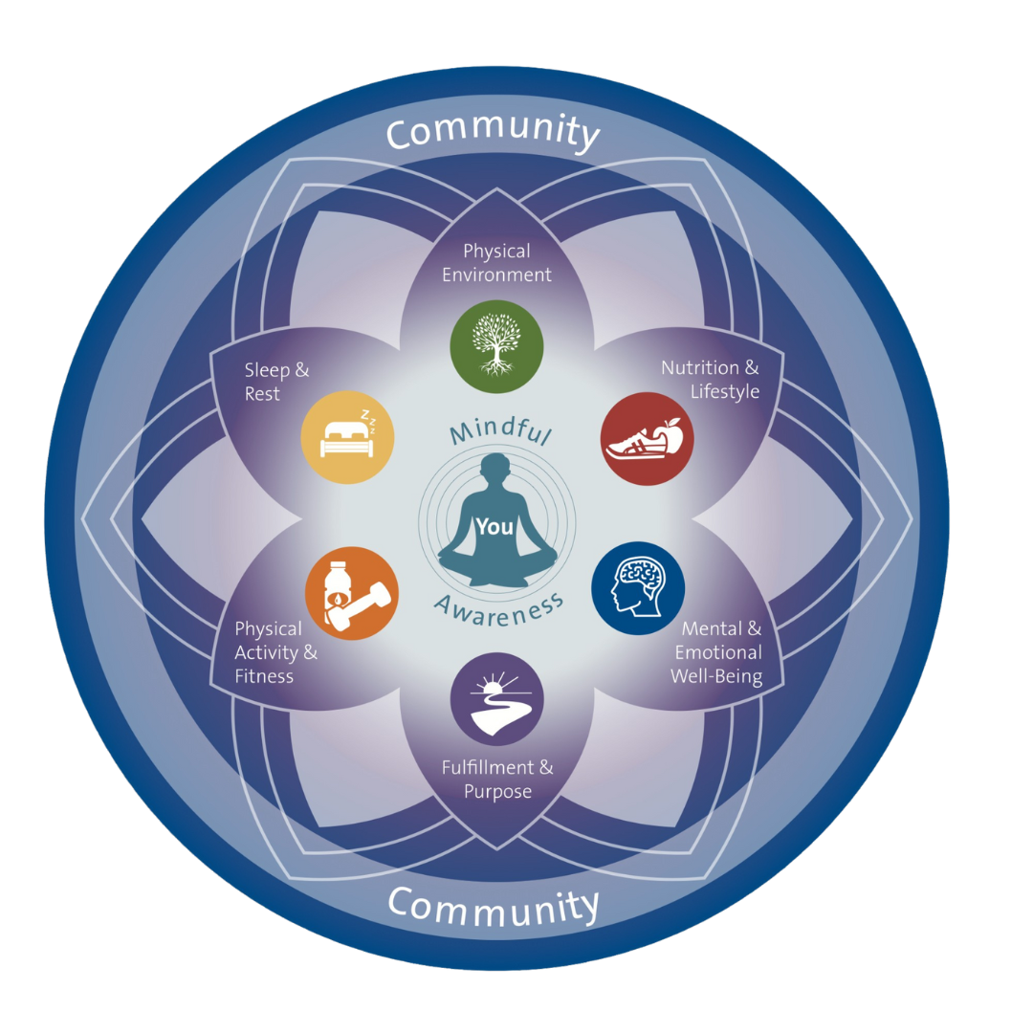

PERSONAL HEALTH INVENTORY

The first step in creating your plan is to complete a Personal Health Inventory to assess where you are now and where you want to be.
1. How do I picture my best health? How would I like to feel and look? What activities would I like to be able to do?

2. What is most important as I think about the picture of my best health?

